Machine Learning Lab Assignment

#### (Provide your code snippets. You may answer the questions with screenshots if applicable.)

**●** - 1 per group

## Explore Microsoft Cognitive Services

Navigate to the <https://azure.microsoft.com/en-us/services/cognitive-services/directory/> page and browse through the available Cognitive Services. There are services for Vision, Speech, Language, Knowledge, and Search.

Find one of the services that is interesting to you. For this part of the lab, you will need to try out the service. (I recommend that you do not select a service from the Knowledge or Search categories.)

There are two ways to try the service:

1. Click “Demo” beside the service description and then use the site to upload your own data. (This is the easy way out…)
2. Actually call the API. This will require that you setup an API Key via the Portal and then call the API from some language. (For example, using [Python](https://docs.microsoft.com/en-us/azure/cognitive-services/computer-vision/quickstarts/python-analyze).)

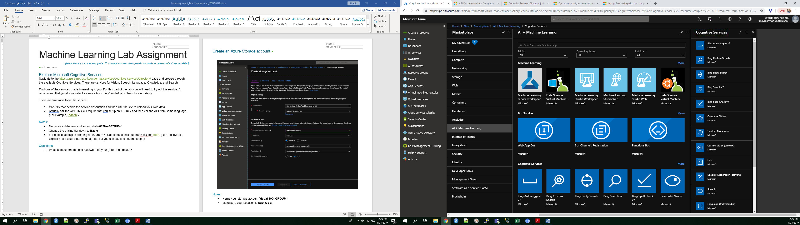

#### Questions

1. What service are you choosing to try out?
2. What data are you sending to the API? (For example, what is the picture, text, or audio file of?)
3. What was the response from calling the API? (Please paste in the full output or JSON response.)
4. Discuss the response. Is there anything that is surprising? Did the service do a good job?
5. Look at the Pricing Calculator for Cognitive Services. How much would your service cost if you needed to make ~25,000 API calls/transactions per month?

## Create an Azure Machine Learning Service Workspace **●**

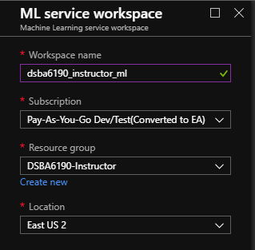

#### Notes:

* Name your service `**dsba6190_<GROUP>_ml**`
* Make sure your Location is **East US 2**.

## Run Through the ML Services Demo

1. Navigate to the ML Service Workspace that your group just created. Click “Get Started in Azure Notebooks”.



1. Clone the project and name the project **<groupname>_<yourname>**.

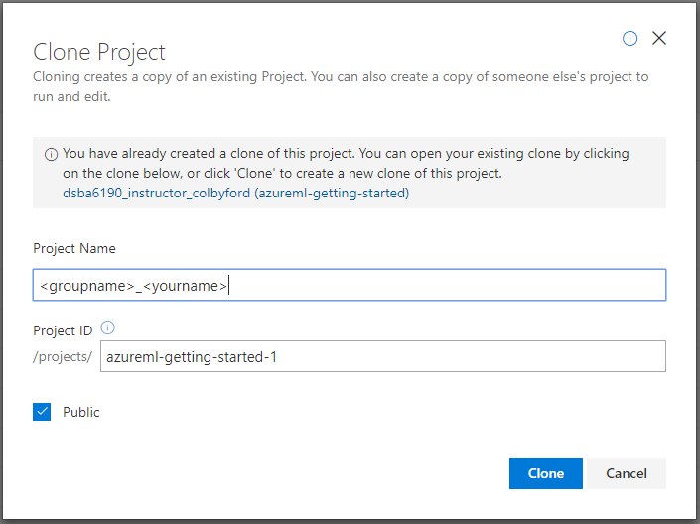

1. Once the project is cloned, navigate to the “tutorials” folder.
2. Run through the “img-classification-part1-training.ipynb” notebook. *(Note: Only part 1 is required for the lab, but you can run through part 2 if you’re interested in deploying models as a service.)*
3. You will need to change some things in the code so that everyone can have an individual result:
   1. When you get to the part about creating an experiment, make sure you rename the experiment_name to **sklearn-mnist_<your_name>**.

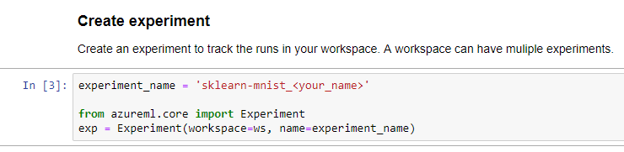

* 1. When you get to the part about creating your own cluster, make sure you rename the cluster in compute_name to **cpucluster_<yourname>**.

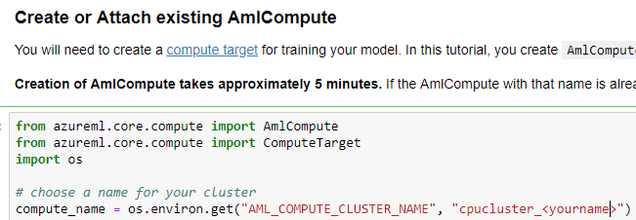

* 1. When you get to the part about creating a training script, make sure you change random_state to **your student ID**.



* 1. When you get to the part about registering the model, make sure you rename the model_name to **sklearn-mnist_<your_name>**.

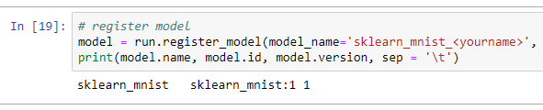

#### Questions

1. Describe the overall process of training a model on a remote cluster. (For example, what resources are needed, how do you get the data, etc.)
2. How large of a cluster did you spin up for training the model? Also, why is it beneficial to specify a minimum and maximum number of cluster nodes?
3. Found under “Train a local model”, what is your model’s accuracy? *(Hint: this is after the* print(np.average(y_hat == y_test)) *bit of code.)*
4. Navigate to your **ML Service Workspace > Experiments**, click on the sklearn-mnist experiment. Provide a screenshot of this panel.
5. Navigate to your **ML Service Workspace > Models**, Provide a screenshot of this panel.
6. Navigate to your **ML Service Workspace > Compute** and DELETE YOUR CLUSTER.
7. Describe why someone would want to train their machine learning model on a cluster in the cloud?
8. Describe why someone would want to deploy their machine learning model in the cloud?
9. What languages are supported in the Azure Machine Learning Service? (Hint: [Here’s the documentation](https://docs.microsoft.com/en-us/azure/machine-learning/service/).)
10. The cluster that you spun up during this exercise uses D2v2 virtual machines. How much would it cost to run the cluster at full size (use your answer from question 2 above) 24/7 for a month?